**DEMO**

**UAT**

Static Content Application Testing on UAT Internet server LTCVOPDCWHIIS01



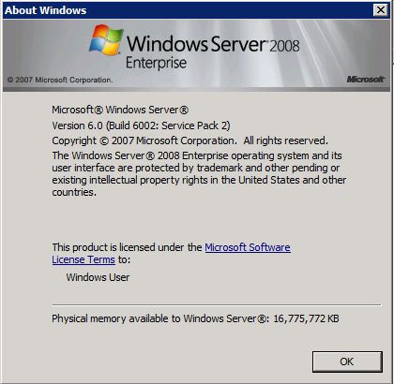

**Application File Name**: Deploy_StaticContent.cmd

**Application Location**: D:\tmp\UAT-implementation\staticDeploy_py

**Test destination for Applications**: D:\tmp\test_web_Roots\MTOWEB-SAE\wwwroot

**Main configuration files:**

D:\tmp\UAT-implementation\staticDeploy_py\static_deploy.properties

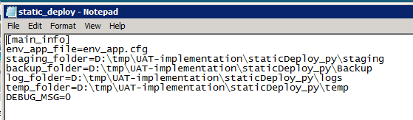

D:\tmp\UAT-implementation\staticDeploy_py\env_app.cfg

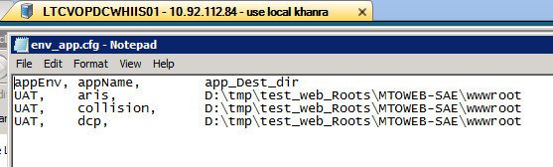

**Command line deployment:**

Test application: aris

Code staging:

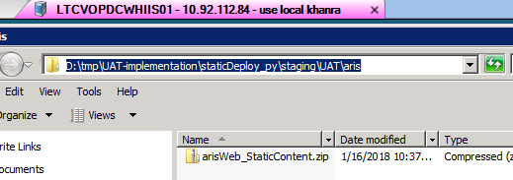

Code deployment:

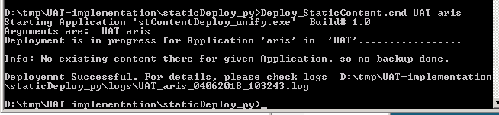

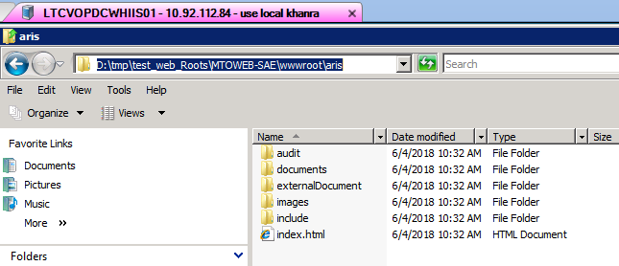

Deployment log:

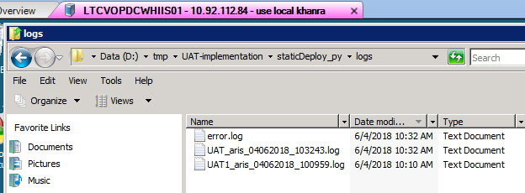

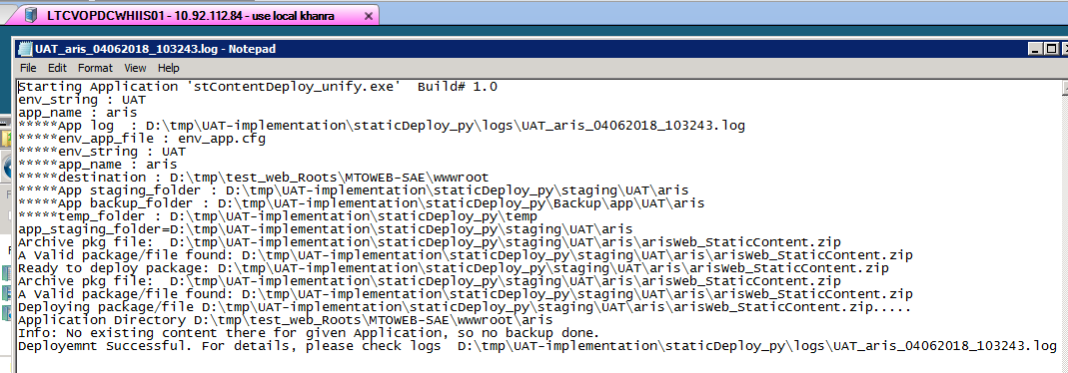

Backups:

Application:

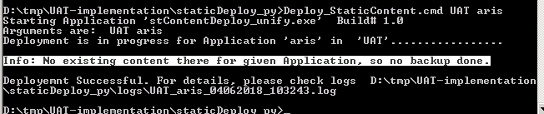

Staged Code:

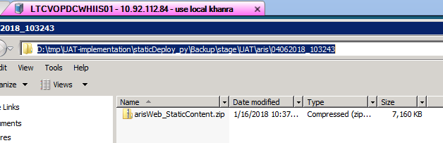

**Deployment using GUI Menu:**

Just enter application command file name ‘Deploy_StaticContent.cmd’ and press ENTER or double click name ‘Deploy_StaticContent.cmd’; it will launch Application GUI menu:

D:\tmp\UAT-implementation\staticDeploy_py > Deploy_StaticContent.cmd

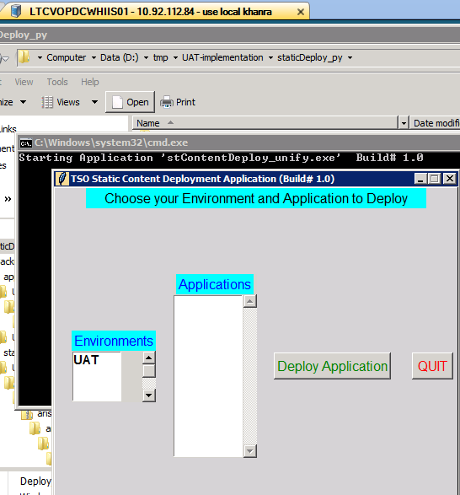

Selecting from Environments list ‘UAT’ will show all related Applications in the Applications List.

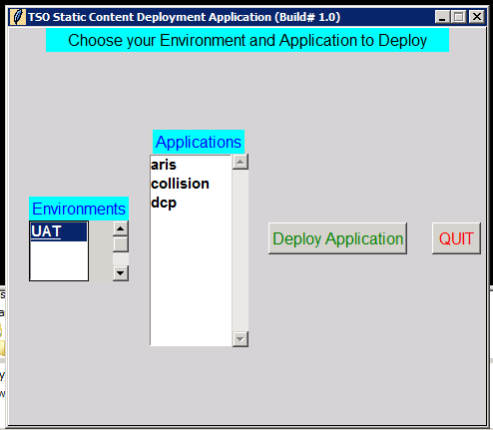

Code staging:



Code deployment:

Select desired Environment and Application from listbox and press “Deploy Application” button. It will show a confirmation dialogue box:

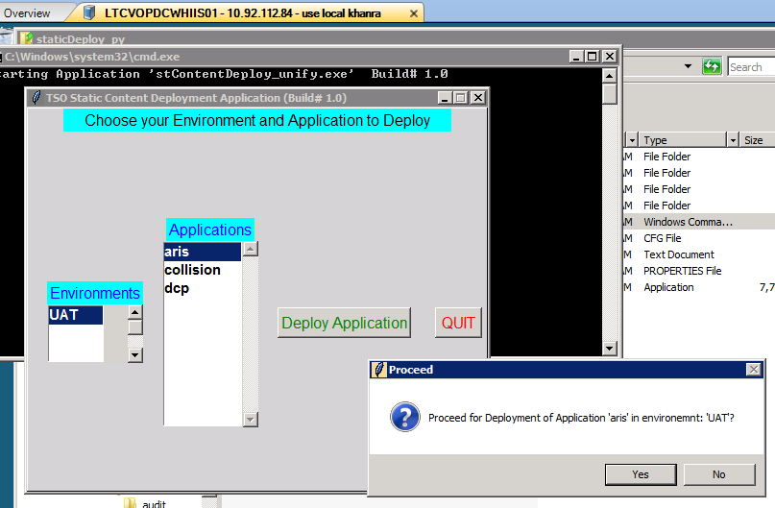

Press ‘Yes’ to proceed and it will deploy application and will show message Success or failure whatever be the case:

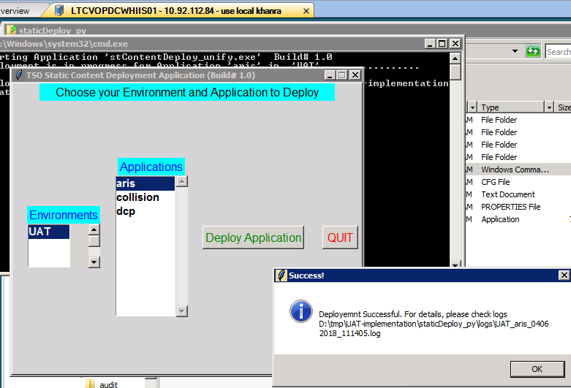

Log:

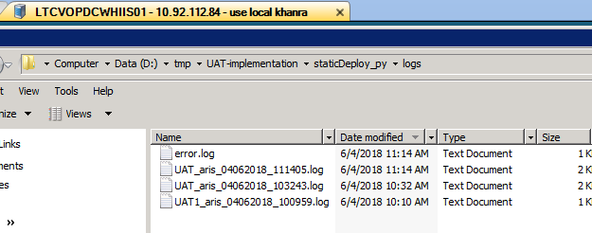

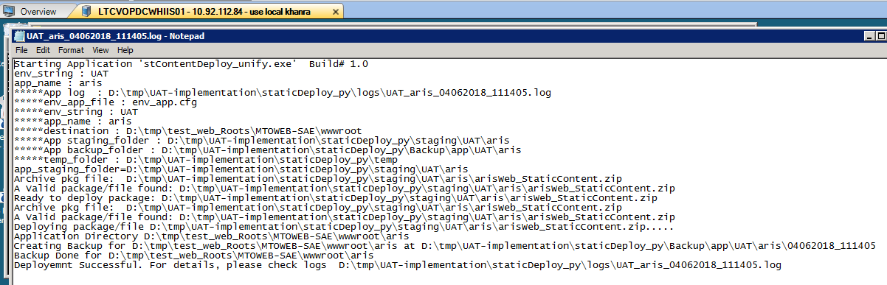

Backups:

Application backup:

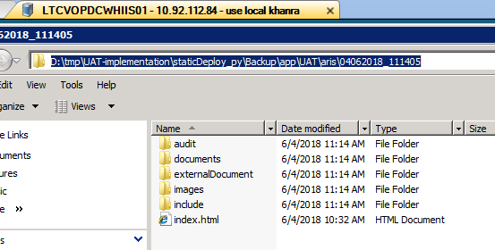

Staged Code backup:

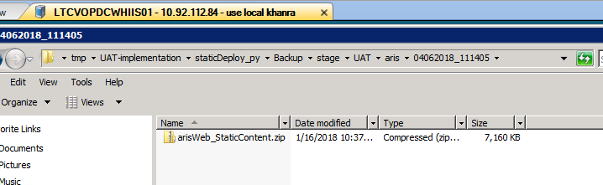

Press “Quit” button to quit the application.